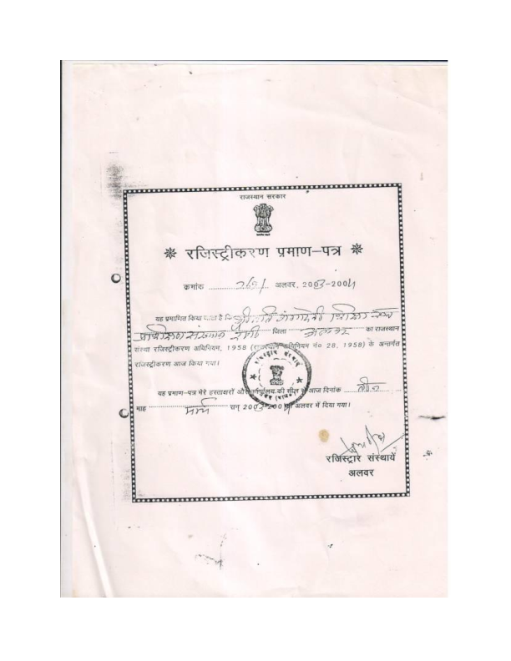v[registration copy samiti](registration%20copy%20samiti)